Threat Intelligence IOC Research – RedLine Stealer Analysis
Analyst: Ugochukwu Sochima Henry

Project Overview
This project focused on conducting threat intelligence research on RedLine Stealer, a widely known information-stealing malware used by cybercriminals to collect sensitive user data such as login credentials, browser information, cryptocurrency wallet details, and other personal information.
The objective of this exercise was to simulate the workflow of a cybersecurity analyst by identifying malware indicators of compromise (IOCs), enriching those indicators using publicly available threat intelligence tools, and building a threat profile based on the findings.
Through this project, I developed practical experience in IOC research, malware investigation, threat enrichment, MITRE ATT&CK mapping, and professional threat reporting.

Objectives
The primary goals of this project were to:
- Research a real-world malware sample.
- Collect and analyze Indicators of Compromise (IOCs).
- Enrich IOC data using threat intelligence platforms.
- Understand malware behavior using MITRE ATT&CK techniques.
- Produce a professional threat intelligence report.

Tools Used
The following tools and platforms were utilized during the investigation:
Tool | Purpose
VirusTotal | Malware scanning, IOC extraction, behavioral analysis
WHOIS DomainTools | Domain registration and ownership lookup
AlienVault OTX | Community-based threat intelligence enrichment
MITRE ATT&CK | Mapping observed malware behaviors to attack tactics/techniques

Methodology

Step 1: Malware Selection
For this project, RedLine Stealer was selected as the target malware family due to its prevalence in modern cyberattacks and publicly available threat intelligence data.
RedLine Stealer is commonly used by attackers to steal:
- Stored browser credentials
- Financial information
- Cryptocurrency wallet data
- System information

Step 2: IOC Collection Using VirusTotal
The malware sample was researched on VirusTotal to identify associated Indicators of Compromise.
The following IOC was extracted:
IOC Type | Value
SHA-256 File Hash | cd12f72ceafd17a5116df84023a2ba502a7c7ae44fe5652573717620a90ab55b
File Name | rifflml.exe

VirusTotal identified the file as malicious with a detection score of:
26/72 Security Vendors Flagged Malicious
This detection score indicates a high probability that the file is malicious and associated with malware activity.

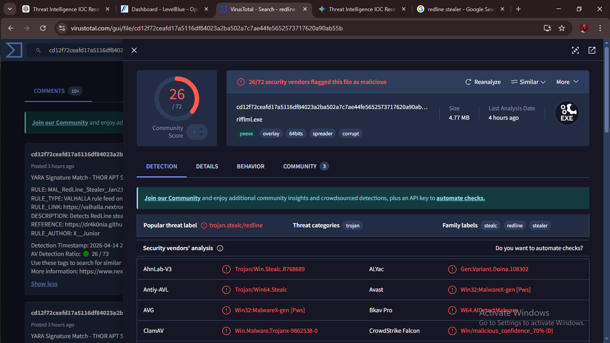

VirusTotal detection result showing file hash, file name, and malicious score.

Step 3: IOC Enrichment and Domain Investigation
Further analysis was conducted using WHOIS DomainTools to gather registration and ownership information related to the suspicious domain associated with the malware sample.
The following information was reviewed:
- Domain registrar
- Registration date
- Hosting IP address
- IP geolocation
- Domain ownership/privacy details
This enrichment process helps determine:
- The legitimacy of the infrastructure
- Suspicious registration patterns
- Geographic hosting origin of threat infrastructure

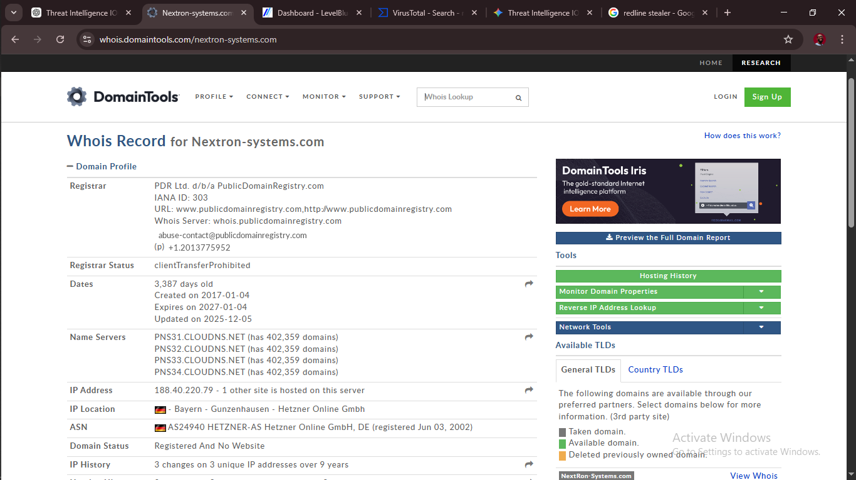
WHOIS lookup results showing registrar, registration date, and hosting information.

Step 4: Malware Behavior and ATT&CK Mapping
The malware sample’s observed behaviors on VirusTotal were mapped to the MITRE ATT&CK Framework.
The following tactics were identified:
ATT&CK Tactic | Technique ID | Description
Execution | TA0002 | Malware executes code on the infected machine
Defense Evasion | TA0005 | Malware attempts to avoid detection by security tools
Discovery | TA0007 | Malware gathers information about the infected system
These observed behaviors indicate that the malware:
- Successfully runs upon execution
- Attempts to remain hidden from detection
- Collects system information for attacker use

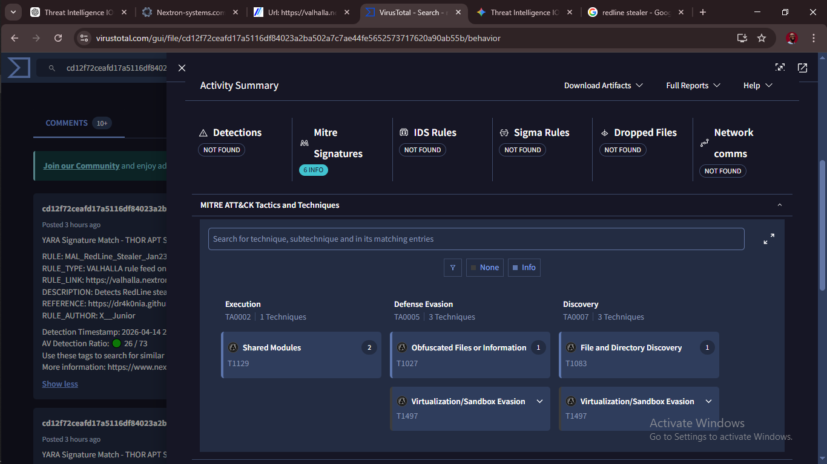
VirusTotal MITRE ATT&CK behavioral analysis showing identified tactics.

Key Findings
Based on the research conducted:
- The analyzed malware sample is highly suspicious and confirmed malicious by multiple antivirus engines.
- The malware demonstrates behaviors consistent with information-stealing malware.
- The sample attempts to evade detection mechanisms, indicating sophistication.
- The malware performs host discovery actions, suggesting reconnaissance before data theft.
- The associated infrastructure displays suspicious characteristics based on WHOIS enrichment.

